MEDIA RELEASE
18th Nov 2015
Adelaide Fringe Festival

CHILRDEN ARE STINKY
Entertainment for your precious little stinkers.

Fresh from a sell out season at the iconic La Mama Theatre and a 5 star review Children are Stinky are thrilled to be coming to Adelaide.
“exceedingly funny” **** Planet Arts
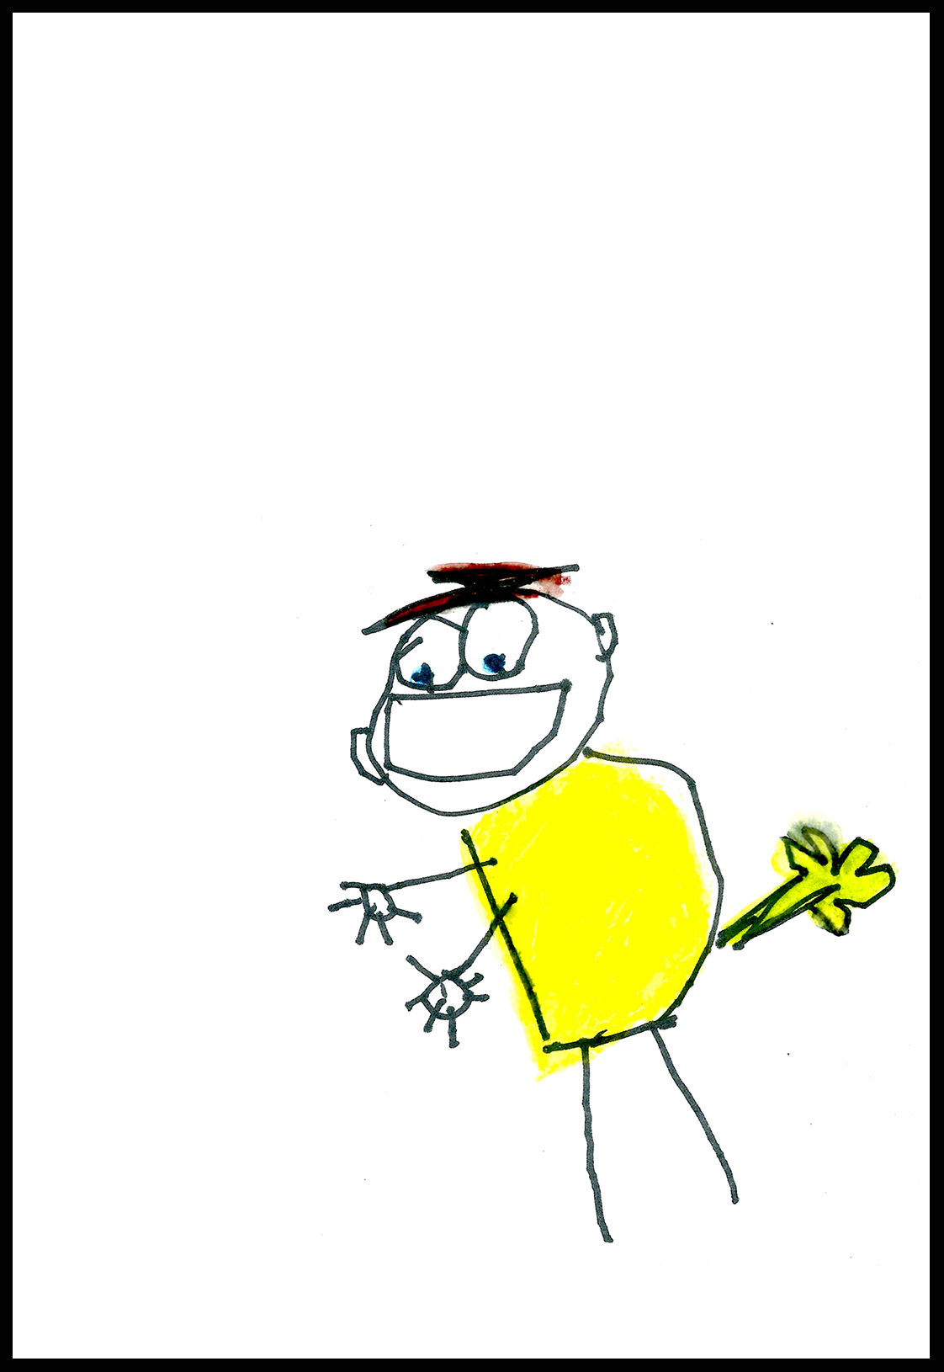
Set as a retro 90’s Children’s Show which quickly becomes derailed by a smell, the duo try to solve the stink problem through sensational circus, silliness and incredible acrobatics but to no avail. Children in the audience are encouraged to step up and become the stars of the show resulting in a hilarious and messy adventure.
Children are Stinky features acclaimed companies Circus Trick Tease and Three High Acrobatics. Playing at La Cascadeur, The Garden of Unearthly Delights as part of the Adelaide Fringe Festival.
Malia Walsh and Chris Carlos are extremely talented performers boasting multiple international professional careers and have a handful of awards under their belts. The two join forces to create a power house performance full of lighting fast Hula Hooping, all the best music from the 90’s, dare devil balances, astounding strength, incredible acrobatics and a healthy dose of comedy.
“…a Comedy Festival treat of physical buffoonery,” The Age
a fast paced performance that will have you in stitches and in awe" RRR
“It's truly hard to find a fault" Australianstage.com
The duo love to be colour and movement for live crosses and photo ops, will do tricks like monkeys…. Just saying.
https://www.facebook.com/kidsarestinky/
http://www.circustricktease.com/
https://www.adelaidefringe.com.au/
http://www.gardenofunearthlydelights.com.au/
Children are Stinky
VENUE: La Cascadeur, The Garden of Unearthly Delights
DATES: 12th Feb till 13th March (Thursday - Sunday)
TIMES: 5pm and 2:45 weekends (45 min)
TO BOOK TICKETS: Visit the Garden or Adelaide Fringe Websites
$20 ALL TIX
CONTACT: Malia Walsh (producer) M: 0417 234 275, E: info@circustricktease.com

