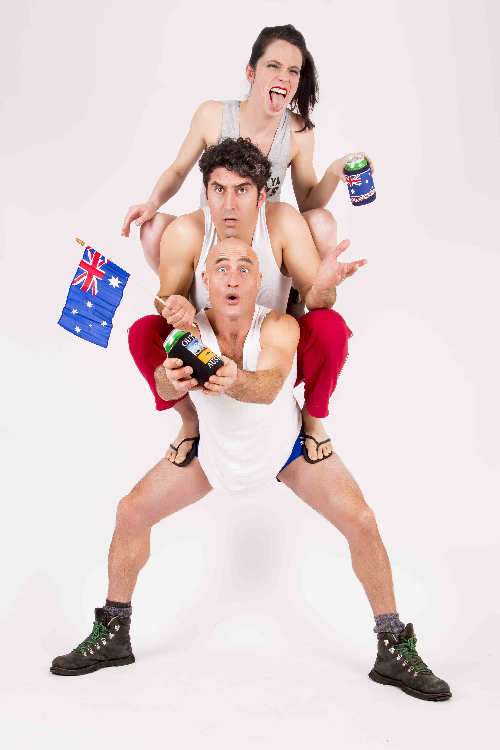
MEDIA RELEASE
18th Nov 2015
Adelaide Fringe Festival

Circus Trick Tease – ‘STRAYA
Circus, Beers and Tricks on the Barbie

‘STRAYA is a tongue-in cheek political satire concerning different ideas of the evolving Australian identity. Told from the perspective of a 5th generation Australian, an American and an Iranian.

Circus Trick Tease was born out of collaboration between Malia Walsh (Men of Steel), Shannon McGurgan (Circus Royal) and Farhad Ahadi (Silvers Circus). The company first appeared at the 2008 Melbourne Fringe Festival where they won The Peoples Choice Award and The ACAPTA Award. They have since performed in countless venues in Australia and internationally.

They team up once again to create an unforgettable show with a power house of talent. ‘STRAYA uses iconicl Australiana to create unique acts and tricks, this trio will amaze you with an action packed circus full of comedy, strength and danger.

Featuring awe inspiring acrobatics, beer can juggling, aerial keg, 3 meter high handstands and (of course) standing on heads. The work is first and foremost a celebration of our nation, poking fun at the good and bad things which make this our Great Southern Land.

“You will walk away amazed, chin to the floor and wanting to see more.” **** Adelaide Advertiser

“This is, without a doubt, a show to go and see” ****1/2 The Public Reviews (Edinburgh)

“A Comedy Festival treat of physical buffoonery.” The Age (Melbourne)

https://www.facebook.com/groups/circustricktease/
http://www.circustricktease.com/
https://www.adelaidefringe.com.au/
http://www.gardenofunearthlydelights.com.au/
Circus Trick Tease – ‘STRAYA
VENUE: Corona Theatre, The Garden of Unearthly Delights
DATES: 12th till 28th Feb (not mondays)
TIMES: 7pm weekends (45 min)
TO BOOK TICKETS: Visit the Garden or Adelaide Fringe Websites
$25 Concession, $30 Adult
CONTACT: Malia Walsh (producer) M: 0417 234 275, E: info@circustricktease.com

